

S.B.

JAIN

INSTITUTE

OF

TECHNOLOGY
MANAGEMENT

& RESEARCH,

NAGPUR

Practical
03

Aim:
Automate student marksheet generation, system information display,
Fibonacci and prime number generation, and file management operations using
shell scripts
to enhance computational efficiency and user interaction.

Name:

Manas Ajay Gupta

USN:
CM24017

Semester / Year:

Academic Session:
Date

of

Performance:
Date of Submission:

- Aim: Automate student marksheet generation, system information display, Fibonacci and prime number generation, and file management operations using shell scripts to enhance computational efficiency and user interaction.

- Tasks to be done in this Practical.
- Write a shell script to generate mark- sheet of a student. Take 3 subjects, calculate and display total marks, percentage and Class obtained by the student.
- Write a menu driven shell script which will print the following menu and execute the given task.
  - Display calendar of current month.
  - Display today’s date and time.
  - Display usernames those are currently logged in the system.
  - Display your terminal number
- Write a shell script which will generate first n Fibonacci numbers like: 1,
1, 2, 3, 5, 13
- Write a shell script which will accept a number b and display first n prime numbers as output.
- Write menu driven program for file handling activity ➢ Creation of file.
  - Write content in the file. ➢ Upend file content.
  - Delete file content

- Objectives:
  - Automate marksheet generation with total, percentage, and class classification.
  - Develop menu-driven scripts for system information and file operations.
  - Generate Fibonacci and prime numbers for user-defined inputs.

- Requirements:
✓ Hardware Requirements:
  - Processor: Minimum 1 GHz
  - RAM: 512 MB or higher
  - Storage: 100 MB free space
✓ Software Requirements:
  - Operating System: Linux/Unix-based
  - Shell: Bash 4.0 or higher
  - Text Editor: Nano, Vim, or any preferred editor

❖ Theory:
Shell scripting is a powerful way to automate repetitive tasks and manage system operations efficiently. It allows users to write programs using shell commands and scripting constructs. Shell scripts are interpreted line-by-line by a shell interpreter, making them ideal for administrative tasks, file management, and system automation. This practical encompasses a variety of real-world scenarios that demonstrate the utility of shell scripting for computing tasks and resource management.
- Marksheet Generation
This script takes input marks for three subjects, calculates the total marks, percentage, and determines the class of the student based on predefined conditions. Conditional statements (if-else) are used to classify the performance into distinction, first class, second class, or fail. This exercise emphasizes the use of arithmetic operations and decision-making constructs.
Key concepts include:
  - Reading user input using read
  - Arithmetic operations with $((expression))
  - Conditional statements for decision-making
- Menu-Driven Script for System Information
Menu-driven scripts enhance user interaction by presenting a list of options for performing different tasks. In this practical, options are provided to display the calendar of the current month, the current date and time, logged-in users, and the terminal number. The script utilizes looping constructs (while) and case statements for structured flow control.

Commands used:
  - cal for displaying the calendar
  - date for showing current date and time
  - who to list logged-in users
  - tty to identify the terminal
- Fibonacci Number Generation
Fibonacci numbers are a sequence where each term is the sum of the two preceding ones. The script uses iterative constructs (for loop) to generate n terms based on user input. This practical illustrates the use of loop control and variable swapping to generate series data efficiently.
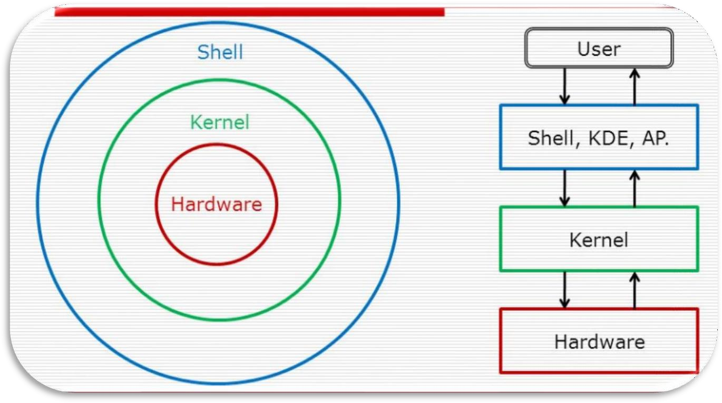
4.

Prime

Number

Display

This

script

accepts

an

integer

n

and

outputs

the

first

n

prime

numbers.

A

nested
loop checks divisibility to determine if a number is prime. The practical
demonstrates logic building for number
-
theoretic operations using loops and
conditionals.

5.

Menu
-
Driven

File

Management

The

file

handling

script

enables

users

to

create,

write,

append,

and

delete

file
content. The case construct manages different file operations.

Commands

include:

•

touch

to

create

files

•

cat

for

writing

and

appending

content

•

rm

for

deleting

files

This

exercise

emphasizes

text

manipulation,

input

handling,

and

file

control
mechanisms in Unix
-
like environments.

Diagrammatical View of
Shell

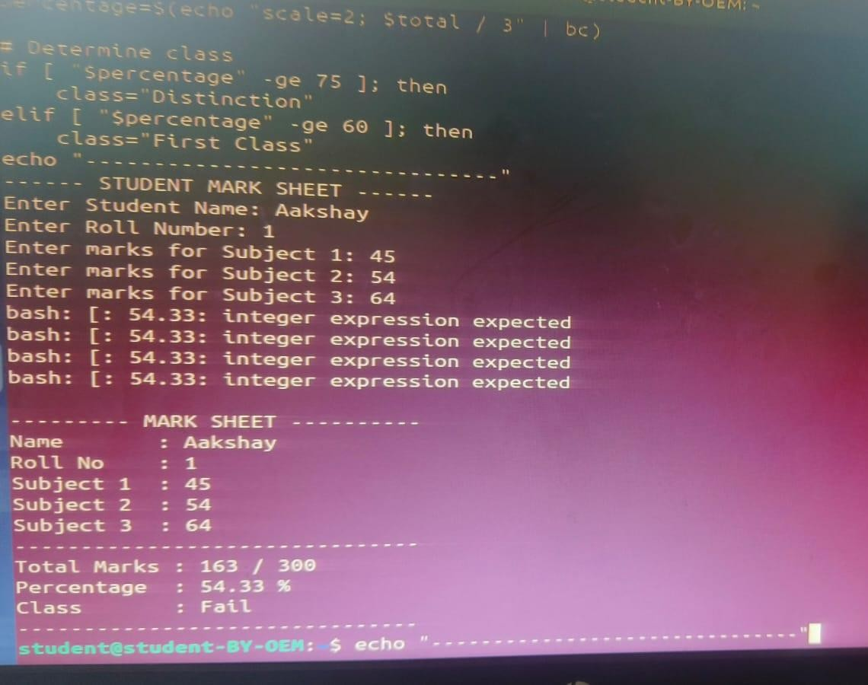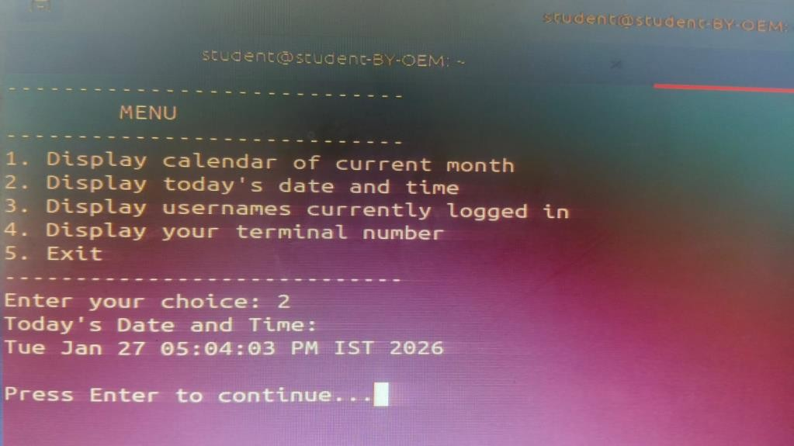
❖

CODES

1.

Write a shell script to generate mark
-

sheet of a student. Take 3
subjects,

calculate

and

display

total

marks,

percentage

and

Class
obtained by the student.

Output

1:

2.

Write

a

menu

driven

shell

script

which

will

print

the

following

menu
and execute the given task.

➢

Display

calendar

of

current

month.

➢

Display

today’s

date

and

time.

➢

Display

usernames

those

are

currently

logged

in

the

system.

➢

Display

your

terminal

number

Output

2:

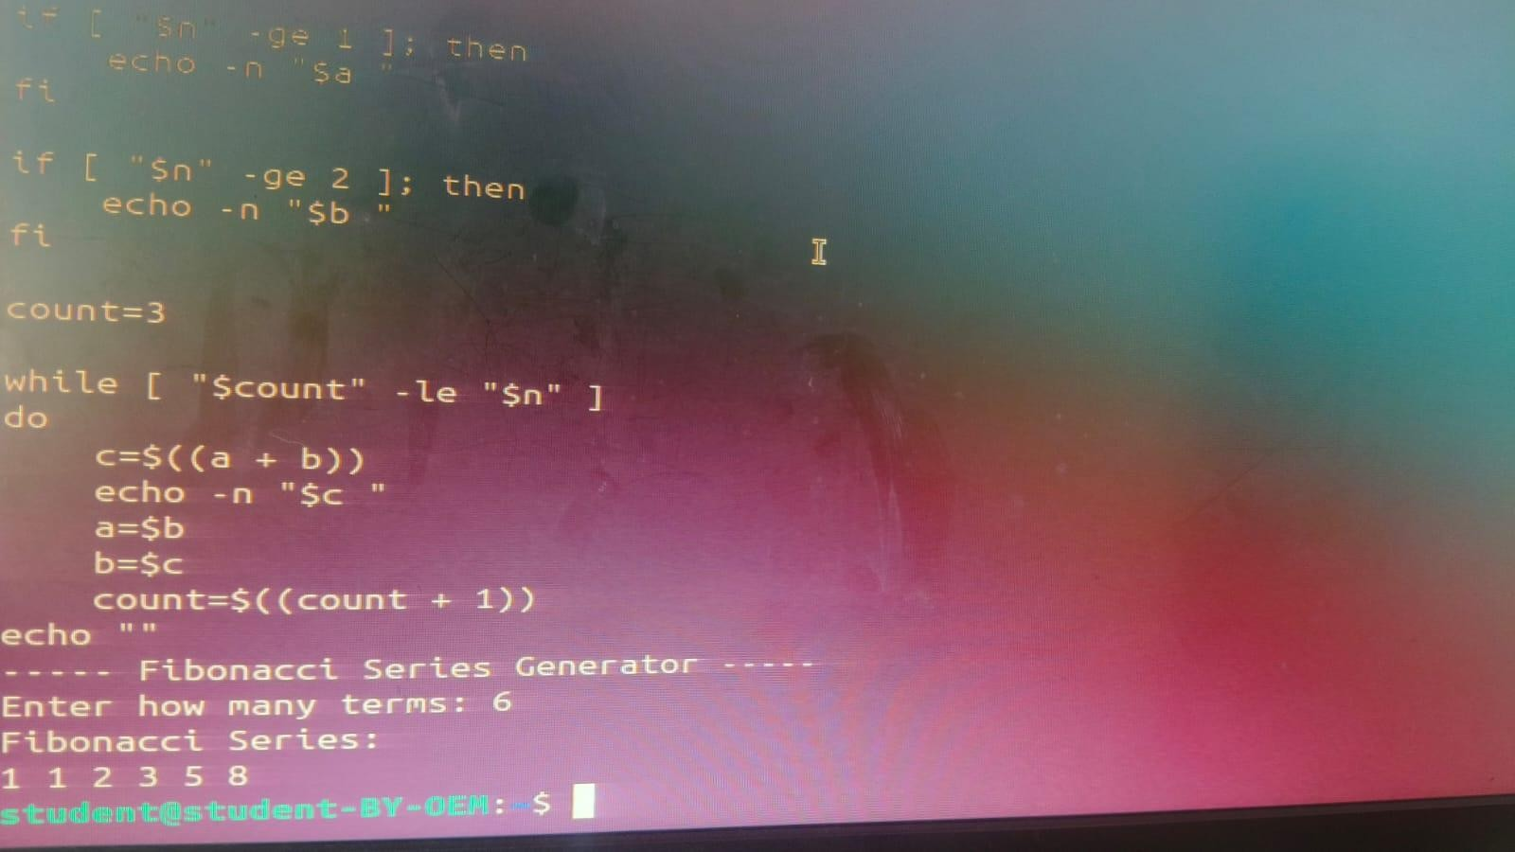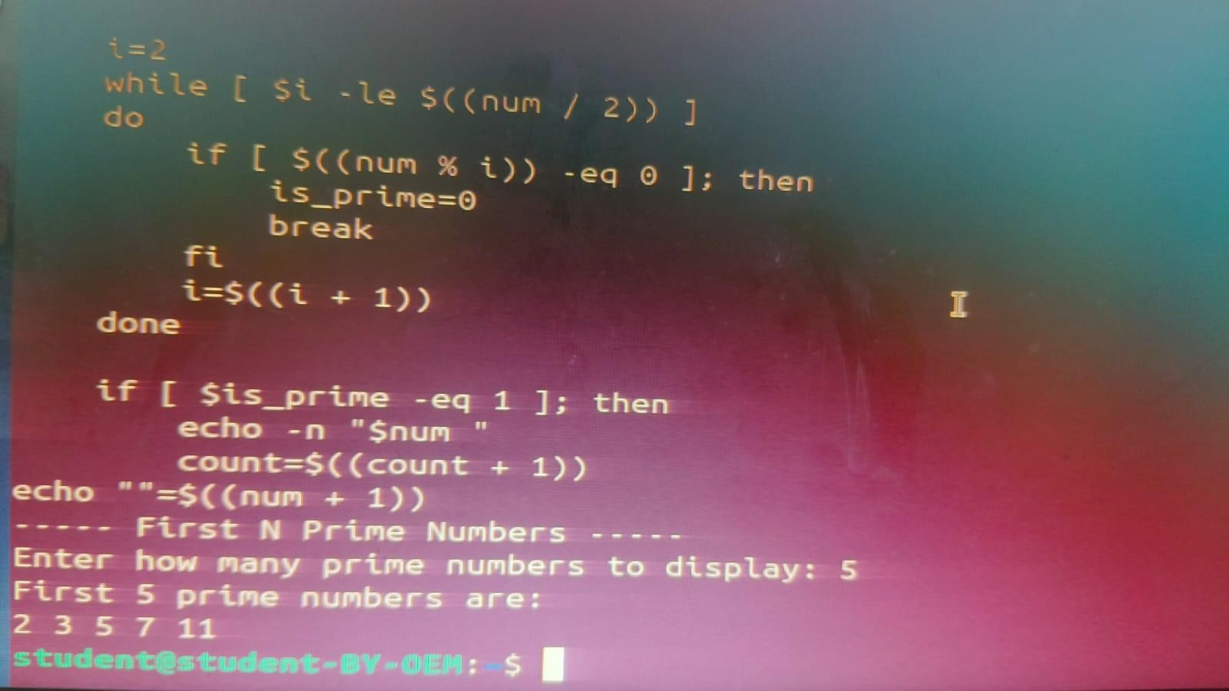
3.

W

rite

a

shell

script

which

will

generate

first

n

Fibonacci

numbers

like: 1, 1, 2, 3, 5, 13

Output

3:

4.

Write

a

shell

script

which

will

accept

a

number

b

and

display

first

n

prime

numbers

as

output.

Output

4:

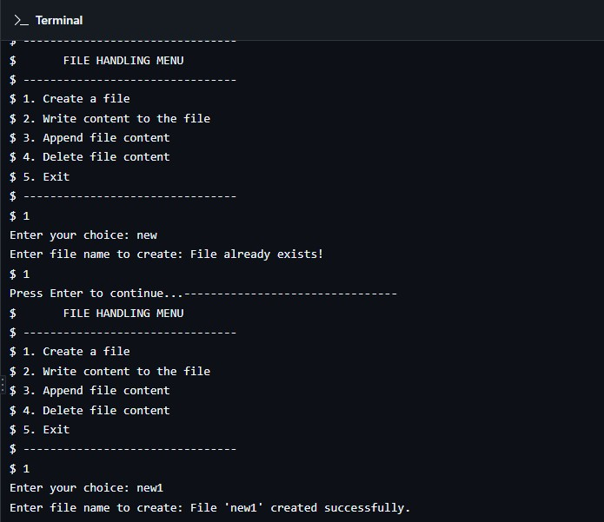
5.

Write

menu

driven

program

for

file

handling

activity

➢

Creation

of

file.

➢

Write

content

in

the

file.

➢

Upend

file

content.

➢

Delete

file

content

Output

5:

- Conclusion: In this practical, we conclude that shell scripting efficiently automates tasks like marksheet generation, system information display, number computations, and file management, enhancing system operations and user interaction through command-line utilities.

- Discussion Questions:
- What is the purpose of using shell scripting in this practical?
- Which command is used to display the current date and time?
- How does the script calculate the Fibonacci sequence?
- Which command is used to create a file in the file management script?
- How does the prime number script determine if a number is prime?

❖ References:
https://www.tutorialspoint.com/unix/shell_scripting.html https://www.javatpoint.com/shell-scripting-tutorial

Date: / /2026 Signature
Course Coordinator
B.Tech CSE(AIML)

Department of Emerging Technologies, SBJITMR, Nagpur.

Department of Emerging Technologies, SBJITMR, Nagpur.

Operating System Lab (N-PCCCM401P)
6.
Department of Emerging Technologies, SBJITMR, Nagpur. Sem: 4 / 2025-26

